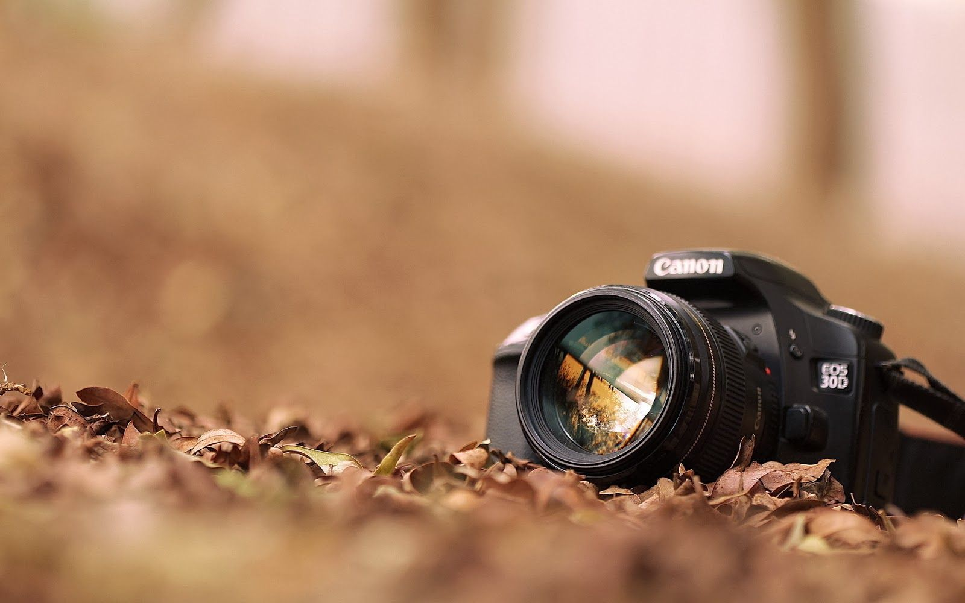

<https://wallpaperaccess.com/hd-photography#google_vignette>

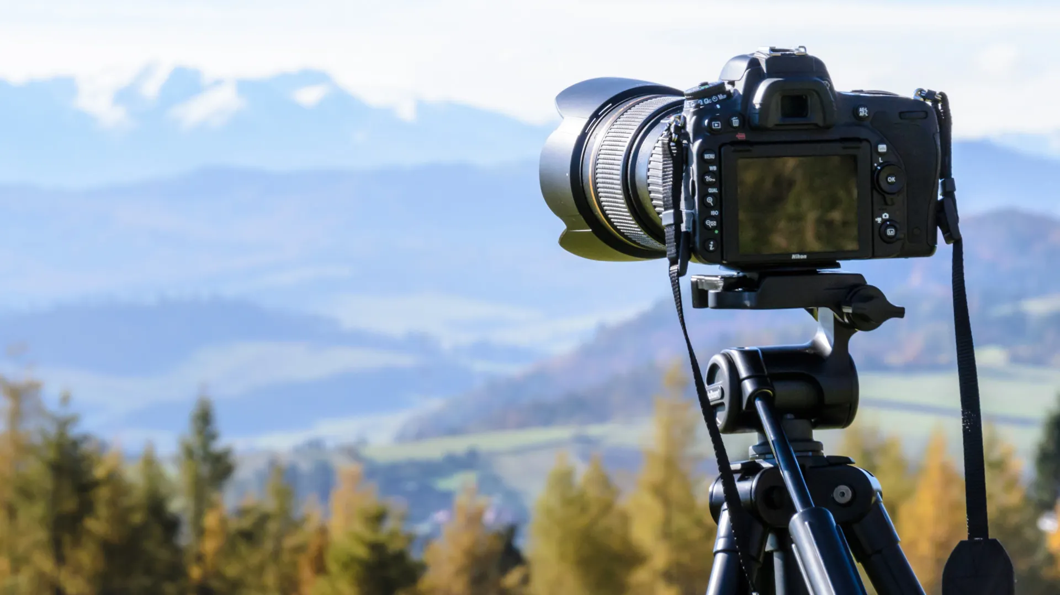

<https://www.template.net/web-templates/website-templates/photography-website-themes/>



https://editzstock.com/wp-content/uploads/2022/05/Camera-lens-logo-png-1-1024x1024.png

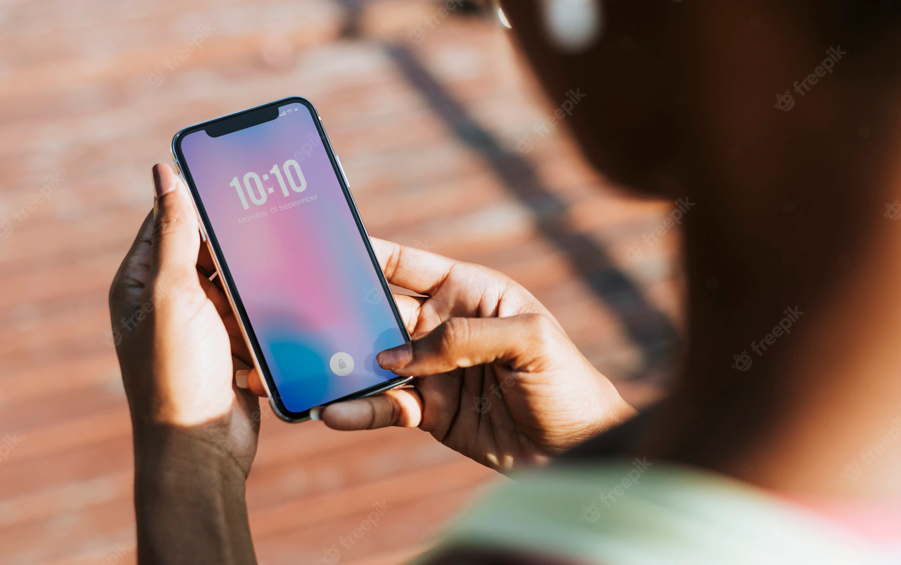

<https://www.freepik.com/free-photos-vectors/phone>



<https://www.dreamstime.com/photos-images/road-trip.html>

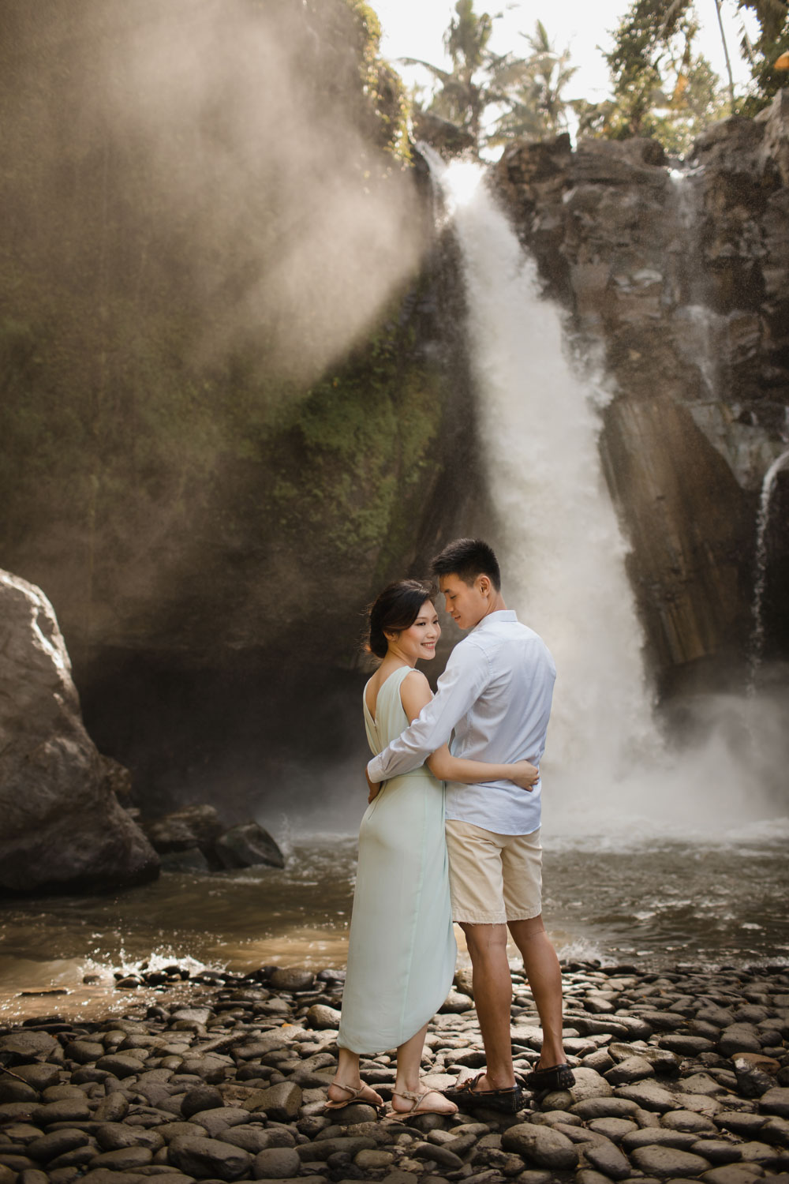

<https://alexandra.bridestory.com/image/upload/assets/bali-pre-wedding-photographer-and-honeymoon-photography-bali-14-Syar9_5cf.jpg>

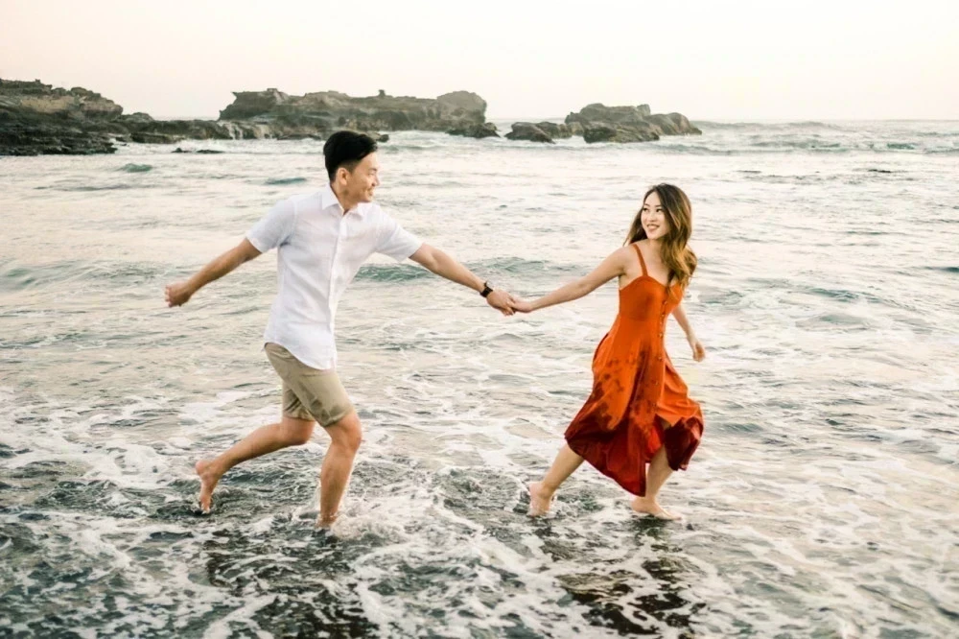

<https://weddingmarket.com/storage/images/artikelideacontent/new/53e461e6303c457bfcd3497db6d3ab1b20686161.webp>



<https://jadimodel.com/wp-content/uploads/2016/08/foto-model-manis.jpg>



<https://emptyphotoproject.com/wp-content/uploads/2021/09/cewek-keren-hunting.webp>



<https://images.pexels.com/photos/1689731/pexels-photo-1689731.jpeg?auto=compress&cs=tinysrgb&dpr=1&w=500>



<https://cdn.pixabay.com/photo/2017/02/20/23/23/girl-2084195_960_720.jpg>

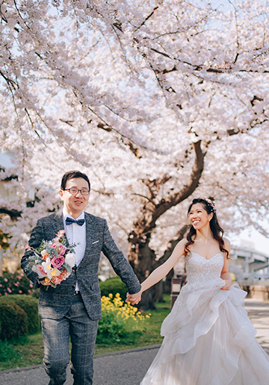

<https://img.onethreeonefour.com/148a0358-a54a-4913-9da5-ccd62126edaa.jpg>



<https://s.kaskus.id/r480x480/images/fjb/2015/05/20/_6434316_1432138054.jpg>

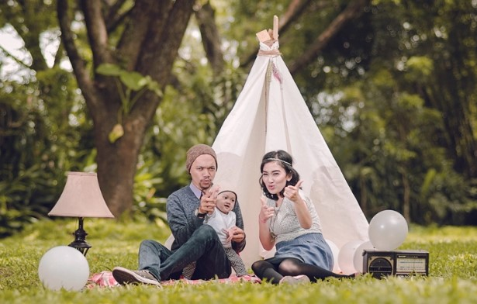

<https://kameradroneterbaik.files.wordpress.com/2017/02/foto-keluarga-outdoor.jpg>



<https://cdn-image.hipwee.com/wp-content/uploads/2019/02/hipwee-b934a50ae085a54a412caccc5f8c767c-640x960.jpg>



<https://blacksweetphoto.com/images/blacksweetphoto/fny8mcGq_178691014_2440532052757038_4832130614050821456_n.jpg>



<https://s0.smartresize.com/wallpaper/1017/212/HD-wallpaper-boy-in-black-and-gray-jacket-sitting-on-brown-grass-during-daytime.jpg>



<https://images.pexels.com/photos/2253879/pexels-photo-2253879.jpeg?auto=compress&cs=tinysrgb&dpr=1&w=500>

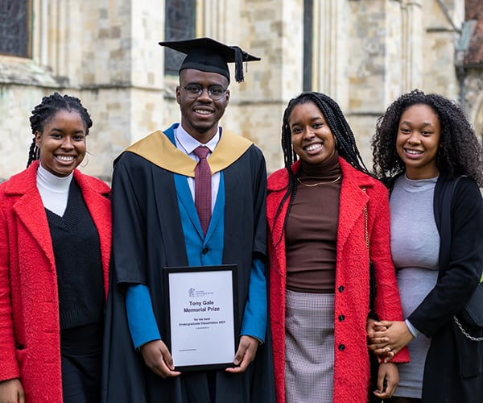

<https://www.chi.ac.uk/app/uploads/2022/03/21-PG-Graduation-600-x-500.jpg>

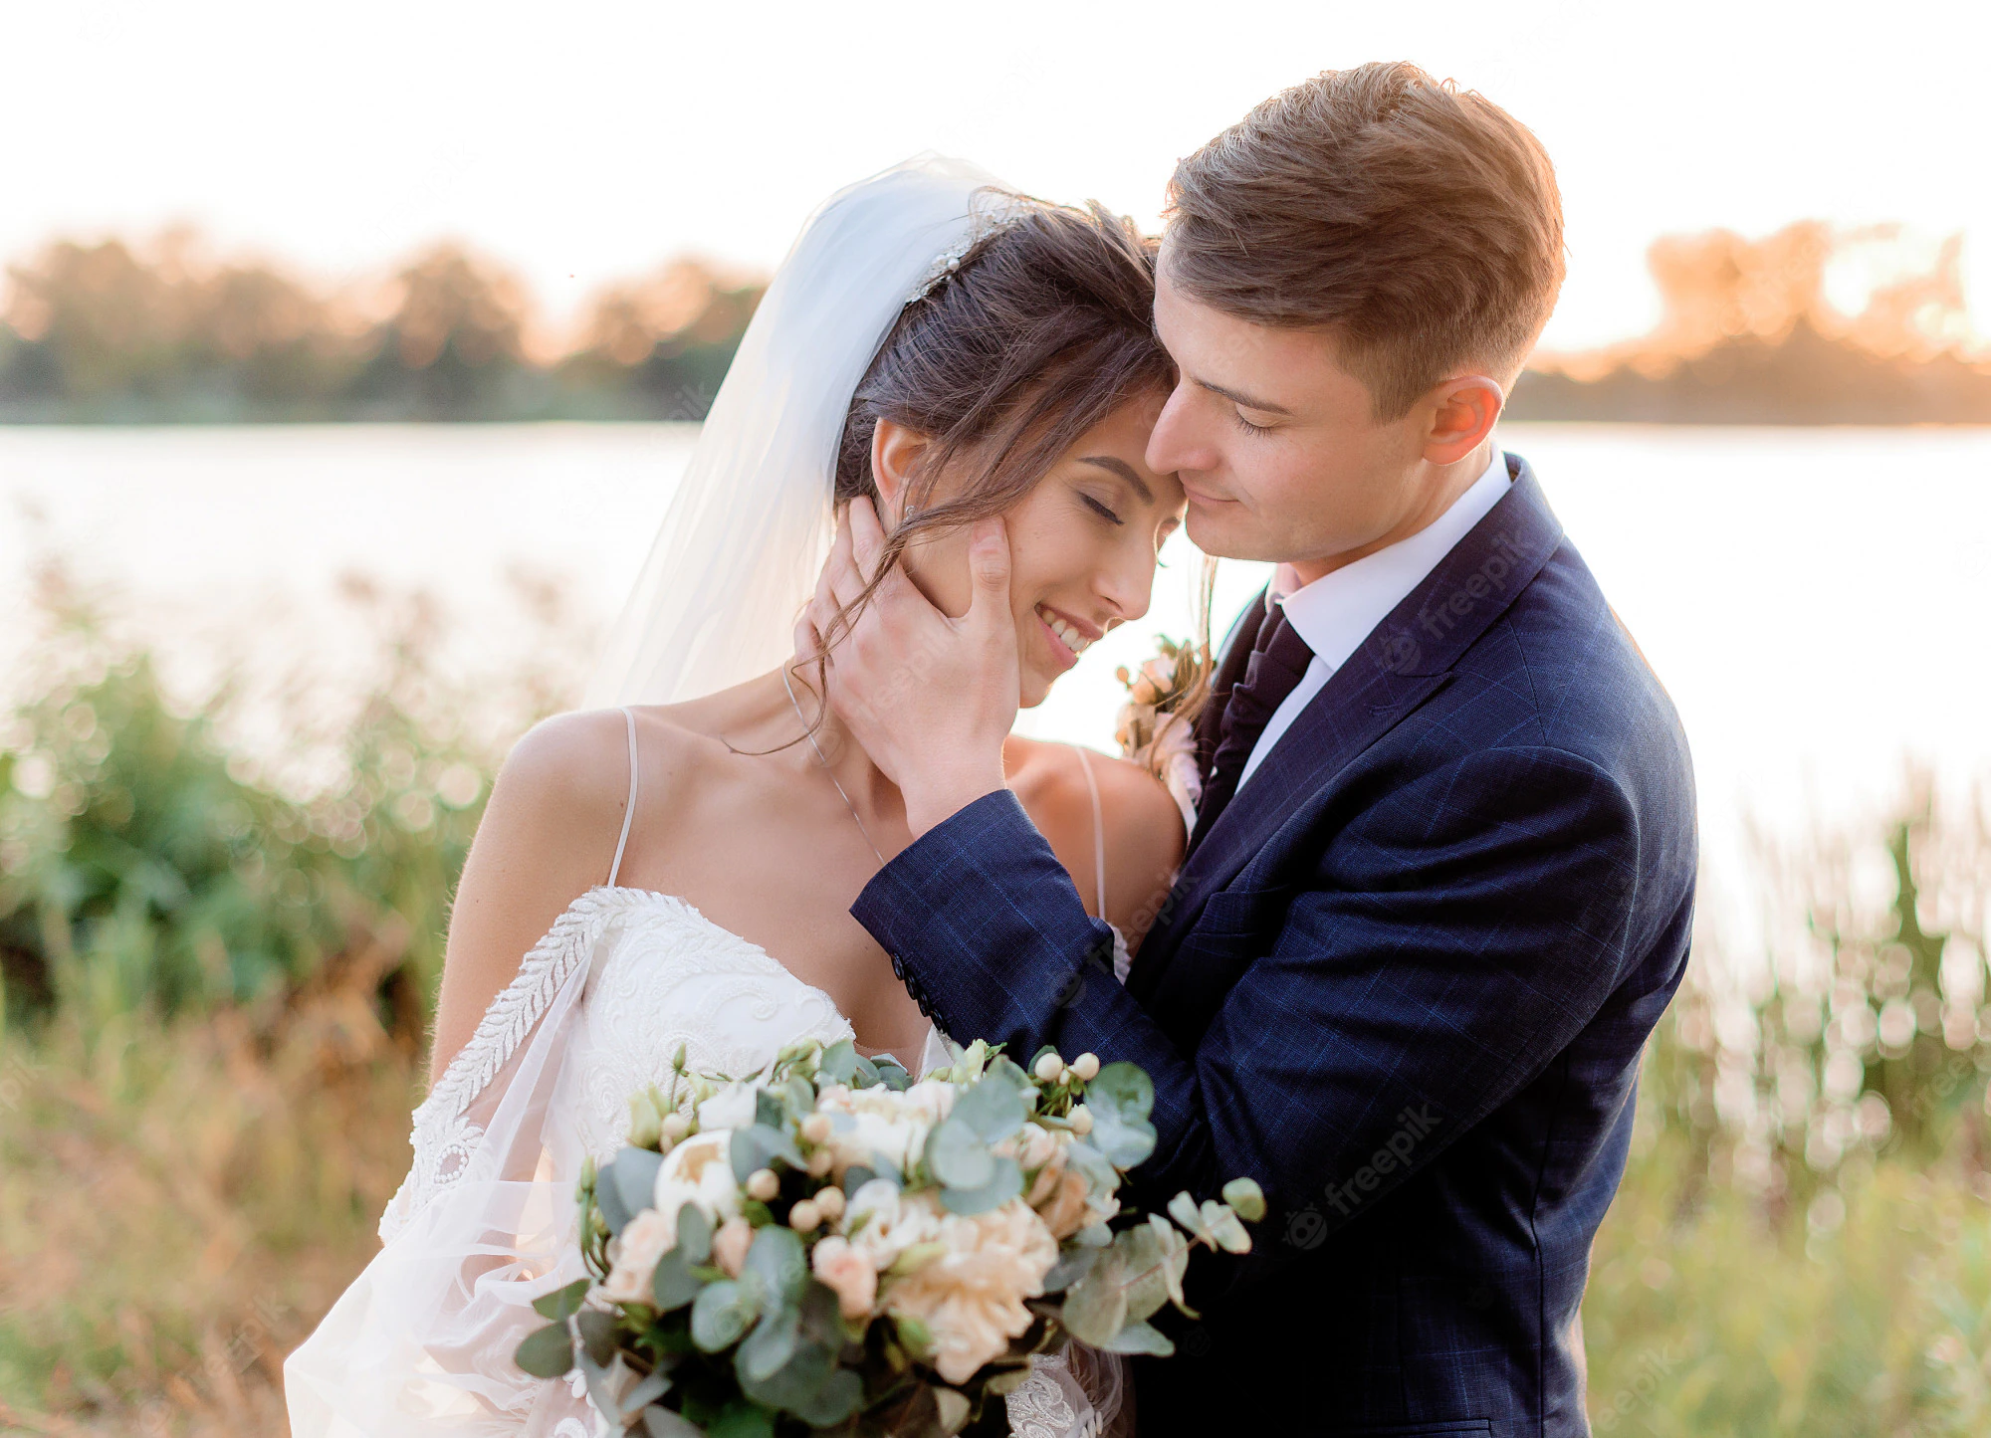

<https://img.freepik.com/free-photo/portrait-tender-wedding-couple-near-water-almost-kissing-with-beautiful-wedding-bouquet-hands-warm-evening_8353-11237.jpg?w=2000>



<https://images.squarespace-cdn.com/content/v1/572fc9ef07eaa0ad6f05e4de/1585175395656-5ICY0P24GN28TBNP0GAO/435A7642%2B%25281%2529.jpg?format=2500w>



<https://global.binus.ac.id/files/2021/05/BInus-Anggrek.jpg>



<https://wallpapers.com/wallpapers/bright-sky-art-fc8pjw6xe32xkl09.html>



<https://ting.blog/wp-content/uploads/Transferring-Texts.jpg>

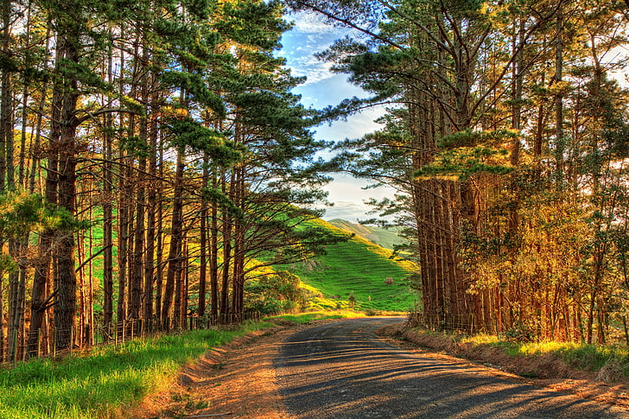

<https://p4.wallpaperbetter.com/wallpaper/226/433/140/road-the-sky-grass-clouds-wallpaper-preview.jpg>



<https://cdn.pixabay.com/photo/2020/03/17/12/01/vietnam-4940057_1280.jpg>



<https://o.dlf.pt/dfpng/smallpng/446-4469341_thumb-image-transparent-background-facebook-icon-black-hd.png>



<https://www.pngmart.com/files/21/Instagram-Logo-PNG-HD.png>



<https://d3k81ch9hvuctc.cloudfront.net/company/Kx4uYL/images/810ea838-998b-4be0-b25a-56c2eb386f46.png?v=0>



<https://st2.depositphotos.com/32990740/44154/v/380/depositphotos_441546664-stock-illustration-whatsapp-logo-symbol-icon-silhouette.jpg?forcejpeg=true>